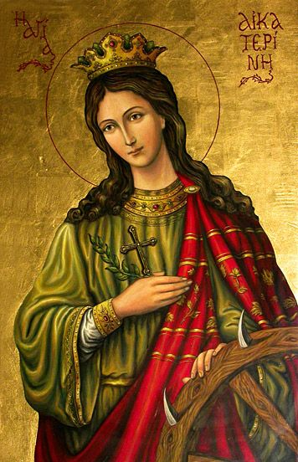Iconography Committee Featured Icon of the Week

Saint Katherine the Great Martyr of Alexandria

Commemorated on November 25

The Holy and Glorious Great Martyr Katherine was the daughter of Constus, the governor, of Alexandrian Egypt. St. Katherine possessed a rare beauty and intellect. She received an excellent education and studied the works of the greatest philosophers and teachers of ancient times. Many young men from worthy families of the empire wanted to marry her however Katherine was not interested. She told her parents she would only marry someone who would surpass her virtue, wealth, beauty and wisdom. Katherine’s mother a secret Christian sent her to her own spiritual Father a Saintly Elder. Before leaving, the Elder handed St. Katherine an Icon of the Theotokos with Christ in Her arms. The Elder then advised her to pray to the Theotokos, and She would grant her heart’s desire. Praying all night St. Katherine envisioned the Theotokos. Christ then spoke to her saying that she was not washed with the waters of the Holy Baptism and not sealed with the Holy Spirit. St. Katherine went back to the Elder and told him what she saw. The Elder instructed her in the Faith of Christ and urged her to preserve her purity, integrity and pray unceasingly. She then received the Holy Baptism. Once again, the Theotokos with Her Child appeared to St. Katherine. Christ looked at her tenderly and gave her a beautiful ring – a gift of the Heavenly Kingdom. (This ring is still on her hands). Years later during the reign of Maximian, persecutions began. St. Katherine went to the emperor to rebuke him for his cruelty. He ordered Katherine to be arrested for confessing Christ and underwent many and various torments. During her confinement angels tended her wounds and was fed daily by a dove from Heaven. In prison with her wisdom she was able to convince hundreds to believe in Christ. Having confessed her faithfulness to Christ and with prayer she laid her head on the block of the executioner sword, was beheaded and received the crown of Martyrdom. The relics of Saint Katherine were taken to Mount Sinai. Pilgrims who visit her monastery receive rings as a remembrance. Saint Katherine is called upon for the relief and assistance during difficult childbirth.

*Apolytikion* **– *Let us praise the most auspicious bride of Christ, the Divine Katherine, protectress of Sinai, our aid and our help. For, she brilliantly silenced the eloquence of the impious by the power of the Spirit, and now, crowned as a martyr, she asks great mercy for all.***

*Kontakion* **– *O friends of martyrs, now divinely raise up a renewed chorus, praising the all-wise Katherine. For, she proclaimed Christ in the arena, trampled on the serpent, and spat upon the knowledge of the orators.***