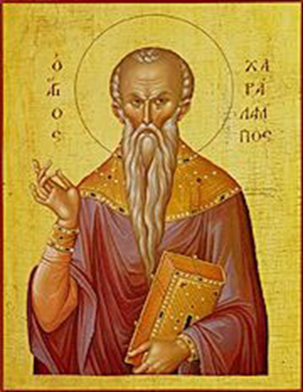Iconography Committee Featured Icon of the Week

Great Martyr Haralambos

Commemorated on February 10

Great Martyr Haralambos was a priest in the city of Magnesia in Thessaly during the late second and early third century. When a terrible persecution began during the reign of Emperor Septimius Severus, the elderly Haralambos did not hide from the persecutors. He freely and openly preached the Christian faith. He endured all tortures as though he were in someone else’s body. When they skinned him alive, the forgiving elder said to the emperor’s soldiers: “Thank you, my brethren, for in scraping my old body you renew my spirit for a new eternal life.” He worked many miracles and converted many to the Faith. Even the emperor’s daughter, Galina, abandoned the idolatry of her father and became a Christian. Condemned to death and brought to the place of execution, St. Haralambos raised his hands to heaven and prayed to God for all people, that God would grant them bodily health and spiritual salvation and that He would multiply their fruit of the earth: “O Lord, Thou knowest that men are flesh and blood; forgive them their sins and pour out Thy grace on all!” After praying, this holy elder gave up his soul to God before the executioner beheaded him in the year 202. The emperor’s daughter, Galina, removed his body and honourably buried it. He was 113 years old when he was tortured and later martyred.

*Apolytikion*- ***O wise Haralambos, you were proven an unshakable pillar of the Church of Christ; an ever-shining lamp of the universe. You shone in the world by your martyrdom. You delivered us from the moonless night of idolatry, O blessed one. Wherefore, boldly intercede to Christ that we may be saved.***