**On Sunday, January 27, 2019, please join us** **for a**

**Parish Bagel Brunch and the Unveiling of our**

**Iconography Program with Sponsorship Opportunities**

***St. Maximus the Confessor***

January 21

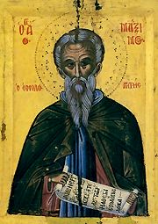

The divine Maximus, who was from Constantinople, sprang from an illustrious family. He was a lover of wisdom and an eminent theologian. He was the chief private secretary of Emperor Heraclius and his grandson, Constans. When the Monothelite heresy (that Jesus Christ had only one will) became predominant in the royal court, out of hatred for this error, the Saint departed for the Monastery at Chrysopolis (Scutari), of which he later became the abbot. When Constans tried to constrain him either to accept the Monothelite teaching, or to stop speaking and writing against it - neither of which the Saint accepted to do - his tongue was uprooted and his right hand was cut off, and he was sent into exile where he reposed in 662. At the time, only he and his few disciples were true Orthodox in the East.

Ultimately, Maximus was exonerated by the Sixth Ecumenical Council as recognized as a Father of the Church.

*Apolytikion:*

*You are a guide of Orthodoxy, a teacher of piety and modesty, a luminary of the world, the God inspired pride of monastics. O wise Maximos, you have enlightened everyone by your teachings. You are the harp of the Spirit. Intercede to Christ our God for the salvation of our souls.*