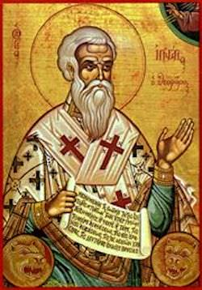**On Sunday, January 13, 2019,**

**please join us** **for**

**The Annual Vasilopita Cutting &**

**The Unveiling of our Iconography Program with Sponsorship Opportunities**

Saint Ignatios

Commemorated on December 20

St. Ignatios was born in 35 A.D. in the Province of Syria. He was the child that Jesus held in the midst of his disciples, saying “Assuredly, I say to you, unless you are converted and become as little children, you will by no means enter the kingdom of heaven (Mt. !8:3).” St. Ignatios later became a disciple of the Holy Apostle John the Theologian. He was also called one of the six Apostolic Fathers because he lived among the Apostles, sharing in their missionary work. He became the Bishop of Antioch in the footsteps of the Apostle Peter. St. Ignatios was a persuasive speaker and prolific writer. His epistles to the churches were written in the format used by Apostle Paul. He urged harmony, obedience to hierarchs, and separation from the heretics. Passing through Antioch, Emperor Trajan ordered St. Ignatios to sacrifice to the idols. A famous dialogue ensured, and when he refused to sacrifice, he was chained and sent to Rome to be thrown to the wild beasts. St. Ignatios rejoiced in the suffering for his Lord. He told the crowd that gathered at the circus that he was the wheat of Jesus Christ, and when he was ground by the teeth of the wild beasts that would devour him, then he would be the pure bread of Jesus Christ. Only a few bones and the Saint’s heart remained. When the pagans cut open the Saint’s heart, they beheld within it in gold lettering “Jesus Christ.” When Trajan heard about the courage of St. Ignatios, he stopped the persecution of the Christians.

St. Ignatios is known to help those with Heart issues.

*Apolytikion* **–*As a sharer of the ways and a successor to the throne of the Apostles, O inspired of God, thou foundest discipline to be a means of ascent to divine vision. Wherefore, having rightly divided the word of truth, thou didst also contest for the Faith even unto blood, O Hieromartyr Ignatius. Intercede with Christ our God that our souls be saved.***